1. Introduction
At its core, biology is an information problem. DNA is a sequence (four characters long) read by molecular machines that produce vastly different outputs depending on context. One gene, one sequence, yet a single cell can use it to generate dozens of distinct functional products. The mechanism behind this is called alternative splicing: a post-transcriptional process by which different segments of a pre-messenger RNA (pre-mRNA) are selectively included or excluded, producing multiple transcript isoforms from a single gene. It is, in essence, a biological multiplexing system.
Understanding which isoforms are expressed, when, and in response to what conditions, is one of the central challenges of modern transcriptomics. This is particularly relevant in the context of circadian biology, where the liver operates on a precise 24-hour molecular clock. Disruption of this clock, through knockout of clock genes such as Per1 and Per2, leads to widespread changes in gene expression and, as recent research from the host laboratory suggests, in the alternative splicing landscape of the murine transcriptome.
This report describes the work carried out during a research internship at the Institut de Genomique Fonctionnelle de Lyon (IGFL), ENS Lyon, from April 27 to August 28, 2026, under the supervision of Dr. Kiran Padmanabhan (Research Director and Group Leader). The internship is part of a BSc in Bioinformatics (Licence Bioinformatique, Portail Informatique, Universite Claude Bernard Lyon 1).
The internship is structured around two sequential projects, both centered on the analysis of alternative splicing in the murine circadian transcriptome. The first project is an exploratory benchmarking study of the SUPPA2 splicing detection tool on Nanopore long-read RNA-seq data. The second, and main, project involves orthogonal validation of the laboratory's findings using publicly available Illumina short-read RNA-seq data. This report covers both projects, presenting the methods and results obtained so far, as well as the plan for the remaining internship period.

2. Host Institution and Research Team

2.1 Institut de Genomique Fonctionnelle de Lyon (IGFL)
The Institut de Genomique Fonctionnelle de Lyon (IGFL) is a joint research unit (UMR 5242) affiliated with the CNRS, the Ecole Normale Superieure de Lyon (ENS Lyon), and the Universite Claude Bernard Lyon 1. Located on the ENS Lyon campus in Lyon, France, it brings together research groups working on genomics, developmental biology, and evolutionary biology, with a shared interest in understanding how genes are regulated and what happens when that regulation changes.
The institute supports both experimental and computational research, with access to high-throughput sequencing, proteomics, and imaging platforms. This makes it a good fit for interdisciplinary projects that combine wet-lab biology with bioinformatics, which is the nature of the work described in this report.

2.2 The Padmanabhan Research Group
The internship is being carried out within the research group led by Dr. Kiran Padmanabhan (Research Director and Group Leader at IGFL). The group studies how the circadian clock, the internal 24-hour timer present in most cells, controls gene activity in the liver. A key focus is the relationship between the clock and RNA processing: not just which genes are turned on or off, but which version of a transcript is produced and how the clock shapes that choice over time. This includes the study of alternative splicing, chromatin organization, and the role of specific regulatory factors in connecting the two.
To generate the data for this project, the group collaborated with Prof. Yutaka Suzuki's lab at the University of Tokyo to perform Nanopore long-read direct RNA sequencing on mouse liver tissue. The experimental design was as follows: wild-type mice were kept in 12-hour light/dark cycles, then transferred to constant darkness one day before tissue collection, to isolate the internal clock from external light cues. Liver samples were collected every 4 hours over 24 hours, covering circadian times CT0 through CT20. A separate group of mice with a double knockout of Per1 and Per2 (PerDKO), which have no functional circadian clock, were also kept in constant darkness and sampled at CT8 (morning phase) and CT20 (evening phase). This setup gives three conditions to compare computationally: wild-type at CT8, wild-type at CT20, and PerDKO at CT20.
The group's most recent findings, currently under review for publication (Chikhaoui, Mamgain et al., unpublished), show that PERIOD proteins influence how splicing regulatory factors are recruited to chromatin, and that this has measurable consequences on which transcript isoforms are produced across the circadian cycle. The computational validation of these findings is the main goal of Project 2 of this internship.

2.3 Team and Working Environment
Day-to-day supervision was provided by Khushi Mamgain (PhD student and co-first author of the manuscript under review), who guided the scientific direction of the analyses and provided the processed Nanopore datasets used in Project 1. Additional input on the computational pipeline for Project 2 was provided by Dr. Bharath Ananthasubramaniam (collaborating computational biologist, based in Berlin), who contributed the starting pipeline scripts. Wet-lab and biochemistry validation of the manuscript's findings is handled by Constanza, a lab member working on the experimental side of the project.
For Project 2, the RNA-seq data comes from a publicly available dataset on NCBI GEO (accession GSE171975), generated by the Asher lab (Aviram et al., 2021) from mouse liver samples at CT20, covering both wild-type and PerDKO conditions. The computational work was carried out on a laboratory-provided Mac workstation, using Bash, Python, and R, with version control managed through GitHub.

3. Scientific and Technical Background

3.1 From gene to isoform: the central dogma and alternative splicing
To understand the computational work carried out in this internship, it helps to have a basic picture of how genetic information flows in a cell. A gene is a region of DNA that encodes a functional product. When a gene is activated, the DNA is first transcribed into a precursor RNA molecule called pre-mRNA. This pre-mRNA contains both coding regions (exons) and non-coding regions (introns). Before the molecule can be used by the cell, the introns are removed and the exons are joined together in a process called splicing, producing a mature messenger RNA (mRNA). The mRNA is then translated into a protein.
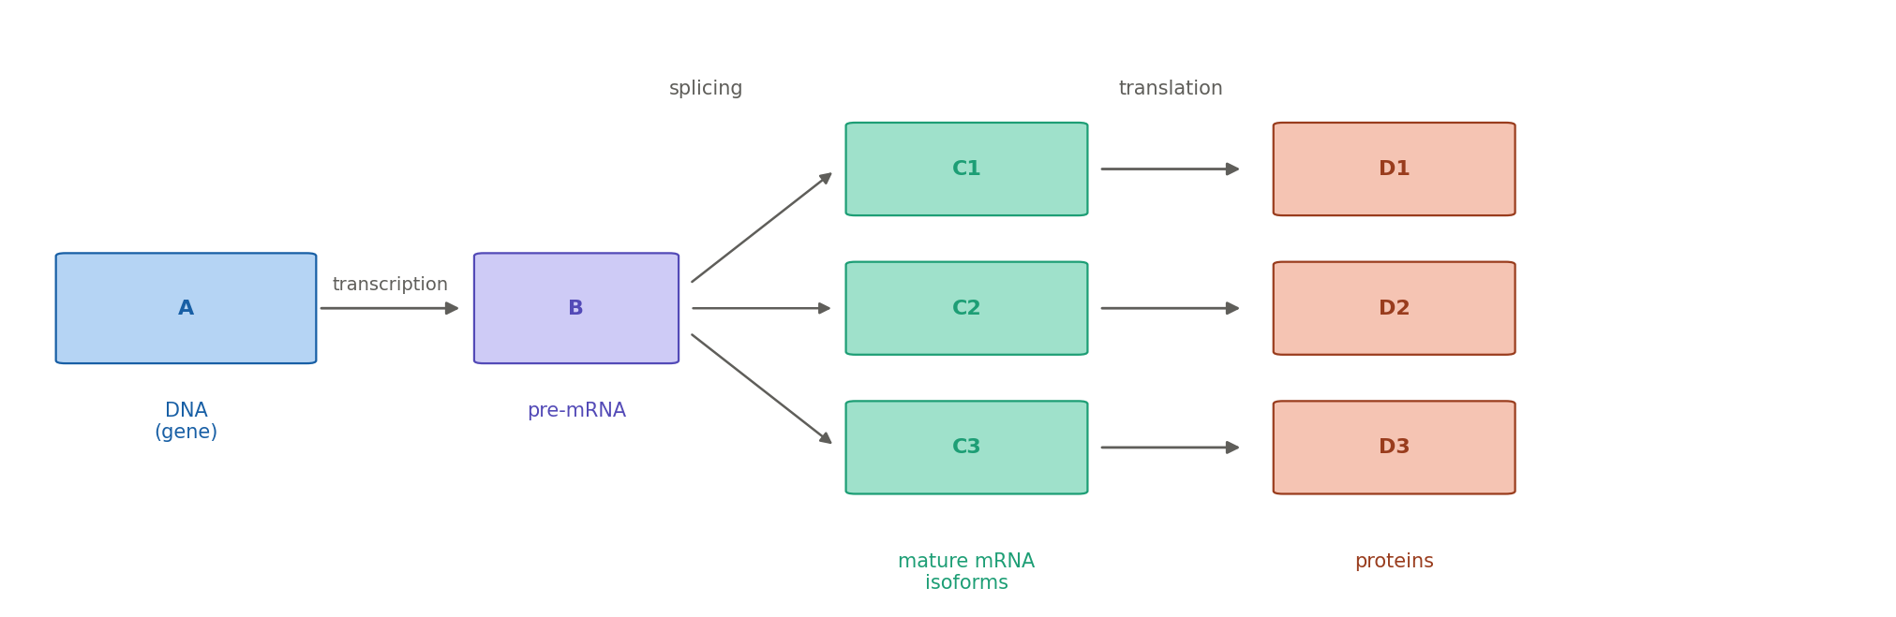
[ Figure 1: central dogma diagram — insert fig1_central_dogma.png here ]
What makes this process particularly interesting from a computational standpoint is that the splicing step is not always identical. Different combinations of exons can be joined, producing distinct transcript isoforms from the same gene. This is called alternative splicing (AS). It is estimated that over 90% of human multi-exon genes undergo alternative splicing (Chikhaoui, 2022), making it one of the main mechanisms by which a relatively compact genome can generate a large diversity of functional products.
Five main types of alternative splicing events have been described and are the ones detected by the SUPPA2 tool used in this project. Each event type describes a different way in which the splicing of a pre-mRNA can vary between two isoforms:
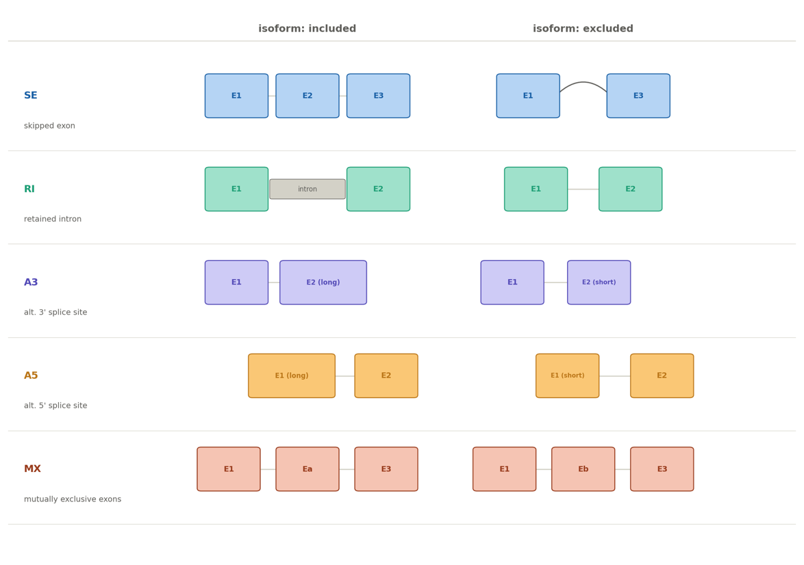
[ Figure 2: AS event types diagram — insert fig2_as_event_types.png here ]
Skipped exon (SE): an exon present in one isoform is completely absent in the other. Exon skipping is the most common event type in mammals (Chikhaoui, 2022).
Retained intron (RI): an intronic region that is normally removed stays in the mature mRNA. This often renders the transcript non-functional and can target it for degradation (Chikhaoui, 2022).
Alternative 3' splice site (A3): the boundary at the 3' end of an intron is shifted, producing an exon that is longer or shorter in one isoform.
Alternative 5' splice site (A5): same idea as A3 but at the 5' end of the intron.
Mutually exclusive exons (MX): two exons are present in the gene, but only one can appear in any given isoform.
The quantification of how often each isoform is produced is captured by a metric called PSI (Percent Spliced In). PSI is a value between 0 and 1 that represents the proportion of transcripts at a given locus that include a particular splicing event. A PSI of 0 means the event is never included; a PSI of 1 means it is always included. When comparing two conditions, the difference in PSI (dPSI) quantifies how much the splicing changes between them. This is the core metric used throughout both projects.
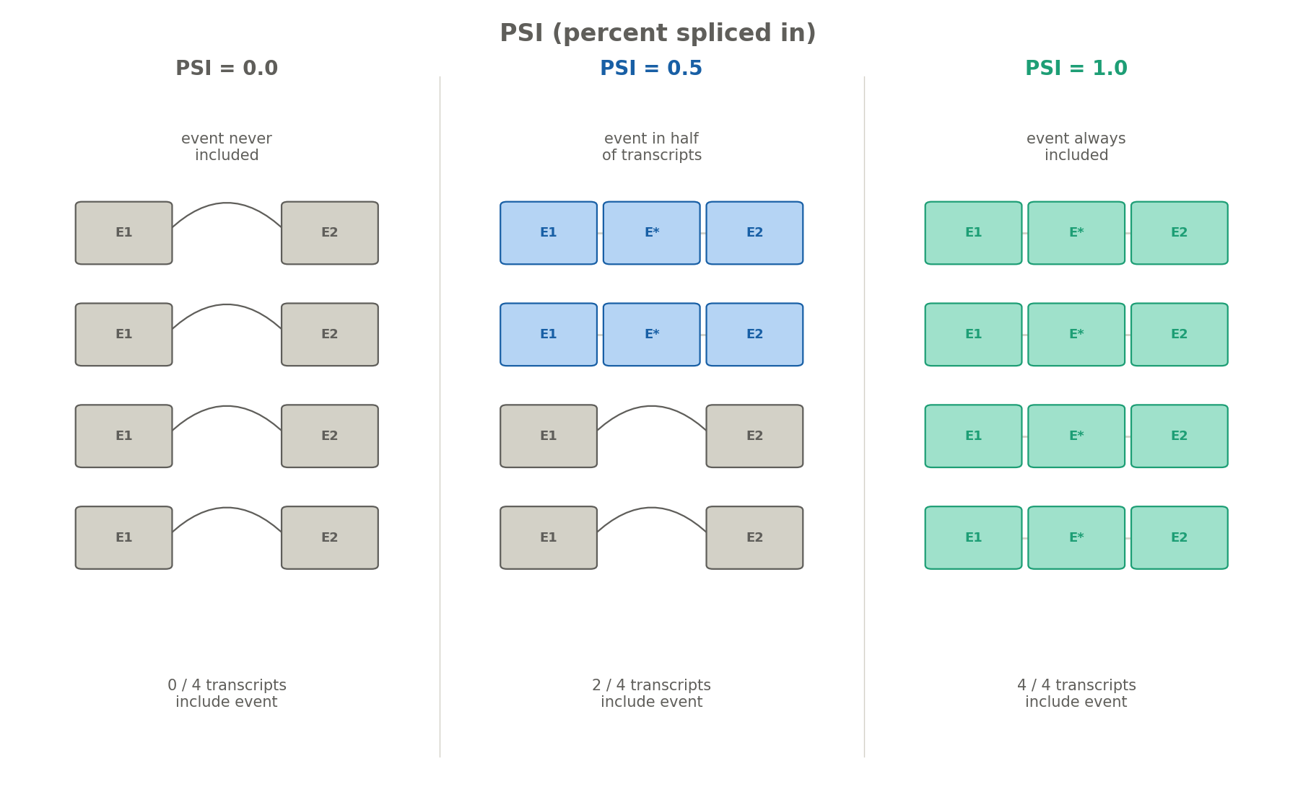[ Figure 3: PSI metric diagram — insert fig3_psi_metric.png here ]

3.2 Circadian context: why alternative splicing matters here
The circadian clock is a molecular feedback loop present in most cells of the body. In the liver, this clock coordinates gene expression over a 24-hour cycle, regulating metabolism, detoxification, and other functions. Previous work from the host laboratory showed that the proteins encoded by the Per1 and Per2 clock genes do not only control transcription, they also influence how splicing regulatory factors are recruited to chromatin. When these proteins are knocked out (PerDKO mice), the splicing landscape of the liver is significantly altered (Chikhaoui, Mamgain et al., unpublished). Earlier analysis using Nanopore long-read sequencing identified hundreds of mis-regulated alternative splicing events in PerDKO mice compared to wild-type (Chikhaoui, 2022), with the strongest signal at CT20, the time point when PER protein levels are at their peak in wild-type animals.
The computational work in this internship sits directly within this context. Project 1 benchmarks the tool used to detect those splicing events. Project 2 aims to validate the findings using an independent dataset generated with a different sequencing technology.

3.3 Two sequencing technologies: Nanopore and Illumina
Both projects involve RNA-seq data, but from two different sequencing platforms. Understanding the difference between them is important for understanding why an orthogonal validation is needed.

 | Nanopore (long-read) | Illumina (short-read)
Read length | Up to ~50,000 nt | ~150 nt
Output | Full-length isoforms | Short fragments
Isoform detection | Direct, unambiguous | Inferred from fragments
Sequencing depth | Lower | Higher
Error rate | Higher (raw reads) | Lower
Use in this project | Primary splicing data (Project 1) | Orthogonal validation (Project 2)

Nanopore long-read sequencing reads entire RNA molecules from end to end, producing reads that can span thousands of nucleotides. This makes it possible to directly observe which exons are present in a single transcript, without having to reconstruct isoforms from fragments. The downside is that it generates fewer total reads per experiment compared to Illumina, and the raw reads have a higher error rate. Illumina short-read sequencing, by contrast, produces millions of short fragments (around 150 nucleotides each). These fragments must be assembled and mapped back to a reference to infer which isoforms were present, which introduces some ambiguity. However, Illumina data is much deeper and more widely available, including in public repositories.
The key point for this project is that both platforms are looking at the same biological phenomenon (alternative splicing) from different angles. If the splicing events detected from Nanopore data are also detectable in independent Illumina data from a comparable experiment, that is strong evidence that the findings are real and not artifacts of the sequencing method.

3.4 Key tools
SUPPA2 is the main splicing analysis tool used in both projects (Trincado et al., 2018). Given a reference transcriptome annotation (a GTF file listing all known transcripts), SUPPA2 first identifies all possible alternative splicing events and their coordinates. It then quantifies each event using transcript expression values (TPM, transcripts per million) produced by a quantification tool. Finally, it computes PSI values per sample and runs a statistical test to identify events that are significantly different between conditions (diffSplice). In this project, the reference annotation used is a custom GTF file derived from the laboratory's Nanopore data, containing 155,263 transcripts including novel isoforms discovered by the lab (Chikhaoui, 2022).
Salmon is a transcript quantification tool (Patro et al., 2017) that takes RNA-seq reads and a reference transcriptome and estimates how much each transcript is expressed (in TPM). It uses a lightweight alignment approach that is very fast compared to traditional aligners. Its output is used directly as input to SUPPA2 for PSI computation. In Project 2, Salmon was also used to re-quantify publicly available Illumina reads against the laboratory's custom transcriptome.
IGV (Integrative Genomics Viewer) is a visualization tool (Robinson et al., 2011) used to inspect splicing events at specific genomic loci. After identifying candidate events computationally, IGV was used to manually verify that the transcript structures detected by SUPPA2 were visually consistent with the underlying read data. This is an important sanity check before reporting any finding.

